**Project Set Up**

Date: 26th March 2024

Prepared By: Team Task Titans

**Conditions of Satisfaction (COS)**

**Request**: The team has received a request from the client to create an innovative fitness application. The application will allow the user to create a profile, track their health, offer personalized recommendations, send reminders, visualize health trends, set goals, and estimate calories from user-uploaded photos. The application shall be available on wearable technology and be compatible with Android and iOS both. The application should provide adequate data privacy and security. The project should be delivered within 1 year and with a budget of $150,000.

**Clarification**: The project will be to create Android (v8+) app and iOS (v12+) apps. The apps will also be available on watchOS and wearOS. The app will have features like profile creation, goal setting (sleep, exercise, and diet), workout recommendations, caloric estimation from photos using a neural network ML model, and health insights. The application will remind users to hit their daily goals and provide end-to-end encryption for all health-related data.

**Response**: The team can satisfy the request within the given time frame and budget. Separate teams will be assigned towards the creation of apps on different platforms, but they will share common UI/UX elements. The team will use a pre-trained neural network to identify the meals and FoodAPI to provide the calorie estimates for those meals. The app will show the user the number of hours slept, calories burned, steps taken, and exercise time alongside the daily/weekly/monthly trend. Users will be allowed to input their goals for each of those categories and select recommended workouts like yoga, calisthenics, and weight exercises. All health data in transit and at rest shall be stored using AES-256 encryption. All features will be subject to unit, integration, and acceptance tests before delivery.

**Agreement**: The client has agreed to the approach used to build the project. The stakeholders have agreed to provide feedback and assistance after each sprint cycle. Any changes will be accepted by the team considering the resource availability, dependencies and current priorities. The apps shall undergo acceptance testing after each cycle to ensure alignment with expectations.

**Priority Prioritizing the Scope Triangle Variables for Improved Change Management**:

|  |  |  |  |  |  |
| --- | --- | --- | --- | --- | --- |
| **Priority Variable** | Critical  (1) | (2) | (3) | (4) | Flexible (5) |
| Scope |  |  | X |  |  |
| Quality | X |  |  |  |  |
| Time |  | X |  |  |  |
| Cost |  |  |  | X |  |
| Resource Availability |  |  | X |  |  |

**Best Fit PMLC Model**

Selection of an appropriate project management lifecycle (PMLC) model is essential for the project's success. An Adaptive PMLC will be used to build NutriScope. The rationale behind the decision is as follows:

1. Changing Requirements: NutriScope is a complex application, and all the requirements are unclear initially. The addition and updating of requirements from stakeholders are expected. The Adaptive PMLC would enable the team to deal with scope changes much more efficiently than other PMLC models.
2. Stakeholder Involvement: The creation and future improvement of NutriScope would require user feedback and stakeholder engagement. The Adaptive PMLC will help the team clearly understand stakeholder needs and user feedback to continuously improve NutriScope, allow for flexibility in feature additions and device integrations, and even manage risks. Risk management is crucial for NutriScope as user information security and reliability are essential considerations.
3. Evaluation: After each cycle, it is important to evaluate the work accomplished. Any unexpected challenges can be discovered early, and successes encountered can be noted. Features like the use of a machine learning model to estimate calories from user-submitted pictures of food require research and identification of key insights to successfully integrate it into the application.

**Requirements Breakdown Structure (RBS)**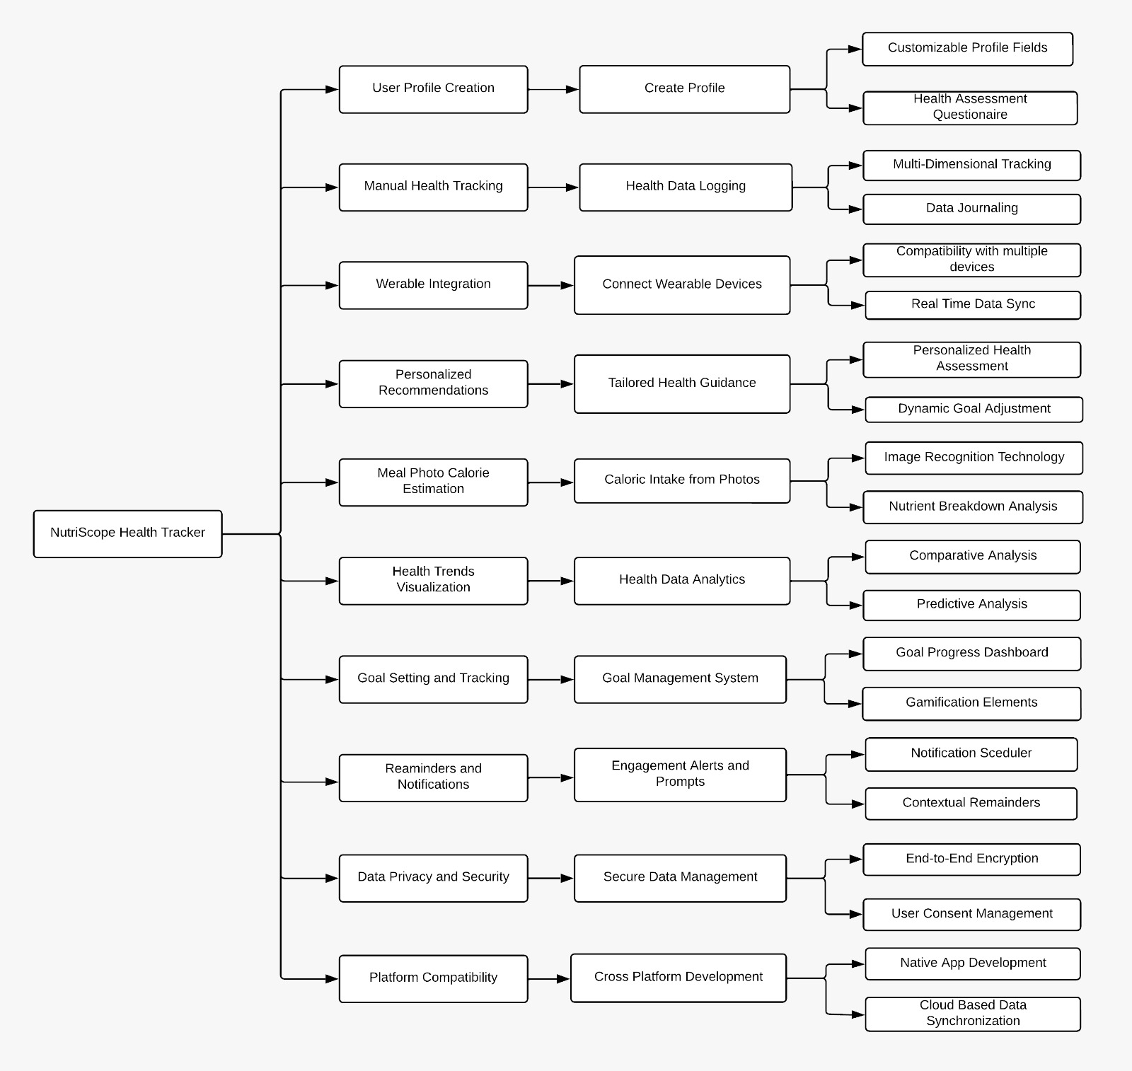

**Responsibility Assignment Matrix for NutriScope (RACI Chart)**

**Prepared by: Team Task Titans Date: 26th March 2024**

|  |  |  |  |  |  |  |  |  |  |
| --- | --- | --- | --- | --- | --- | --- | --- | --- | --- |
| **WBS Activities** | **NHT-1.1.1** | **NHT-1.1.2** | **NHT-1.1.3** | **NHT- 1.1.4** | **NHT-1.1.5** | **NHT-1.2.1.1** | **NHT-1.2.1.2** | **NHT- 1.2.1.3** | **NHT-1.2.1.4** |
| **OBS Units** |  |  |  |  |  |  |  |  |  |
| **Jayesh Pamnani** | **C, I** | **R, A** | **R, A, C, I** | **C, I** | **C, I** | **C, I** | **I** | **I** | **C, I** |
| **William Dzialak** | **C, I** | **I** | **R, C, I** | **C, I** | **I** | **R, A** | **I** | **I** | **C, I** |
| **Manav Gupta** | **C, I** | **R, C, I** | **R, C, I** | **C, I** | **R, C, I** | **I** | **R, C, I** | **R, A** | **R, A** |
| **Kunal Haryani** | **R, C, I** | **I** | **R, C, I** | **C, I** | **R, A** | **I** | **R, A** | **R, C, I** | **R** |
| **Bhanu Panguluri** | **R, A, I** | **I** | **R, C, I** | **R, A** | **I** | **I** | **C, I** | **C, I** | **C, I** |

|  |  |  |  |  |  |  |  |  |  |  |
| --- | --- | --- | --- | --- | --- | --- | --- | --- | --- | --- |
|  |  |  |  |  |  |  |  |  |  |  |

|  |  |  |  |  |  |  |  |  |  |  |  |  |  |  |
| --- | --- | --- | --- | --- | --- | --- | --- | --- | --- | --- | --- | --- | --- | --- |
| **WBS Activities** | | **NHT-1.2.2.1** | **NHT-1.2.2.2** | **NHT-1.2.2.3** | **NHT- 1.2.2.4** | **NHT-1.2.3.1** | **NHT-1.3.1.1** | | **NHT-1.3.1.2** | | **NHT- 1.3.1.3** | | **NHT-1.3.1.4** | |
| **OBS Units** | |  |  |  |  |  |  | |  | |  | |  | |
| **Jayesh Pamnani** | | **I** | **I** | **C, I** | **I** | **R, A, C** | **I** | | **I** | | **I** | | **I** | |
| **William Dzialak** | | **I** | **I** | **I** | **I** | **R** | **I** | | **I** | | **I** | | **I** | |
| **Manav Gupta** | | **R, C** | **R, C, I** | **R, A, C** | **R, A, C** | **I** | **R, C** | | **R, A, C** | | **R, A, C** | | **R, A, C** | |
| **Kunal Haryani** | | **R, A, C** | **R, A, C** | **C, I** | **R, C** | **I** | **R, A, C** | | **R, C** | | **R** | | **R** | |
| **Bhanu Panguluri** | | **R** | **I** | **C, I** | **R, C** | **I** | **R, C, I** | | **R, C** | | **R** | | **R** | |
| **WBS Activities** | **NHT-1.4.1.1** | | **NHT-1.4.1.2** | **NHT-1.4.1.3** | **NHT- 1.4.1.4** | **NHT-1.4.1.5** | **NHT-1.4.2** | **NHT-1.4.3** | | **NHT- 1.4.4** | | **NHT-1.4.5** | |
| **OBS Units** |  | |  |  |  |  |  |  | |  | |  | |
| **Jayesh Pamnani** | **I** | | **C, I** | **R, C, I** | **I** | **I** | **I** | **I** | | **I** | | **I** | |
| **William Dzialak** | **I** | | **I** | **I** | **I** | **I** | **I** | **I** | | **I** | | **I** | |
| **Manav Gupta** | **R, C** | | **R, A** | **R, A** | **R, A, C** | **R, A** | **R** | **R, A, C** | | **I** | | **R, A** | |
| **Kunal Haryani** | **R, A** | | **R, C** | **R** | **C** | **R** | **R** | **R** | | **R, A, C** | | **R** | |
| **Bhanu Panguluri** | **R** | | **R** | **R** | **R** | **R** | **R, A, C** | **R** | | **I** | | **R** | |

|  |  |  |  |  |  |  |  |  |  |  |
| --- | --- | --- | --- | --- | --- | --- | --- | --- | --- | --- |
|  |  |  |  |  |  |  |  |  |  |  |

|  |  |  |
| --- | --- | --- |
| **WBS Activities** | **NHT-1.5.1.1** | **NHT- 1.5.1.2** |
| **OBS Units** |  |  |
| **Jayesh Pamnani** | **R, A, C** | **R, A** |
| **William Dzialak** | **I** | **I** |
| **Manav Gupta** | **R** | **I** |
| **Kunal Haryani** | **R** | **I** |
| **Bhanu Panguluri** | **R** | **R, C** |

|  |  |  |  |  |  |  |  |  |  |  |
| --- | --- | --- | --- | --- | --- | --- | --- | --- | --- | --- |
|  |  |  |  |  |  |  |  |  |  |  |

**Key:**

* **R – Responsible: Person responsible for the task.**
* **A – Accountable: Person accountable for the completion of the task.**
* **C – Consulted: Person with the necessary information to complete the task.**
* **I – Informed: Person notified of task status and results.**